센서 관련 내용
Readme
자율주행 차량은 주변 환경을 인식하고 자신의 위치를 파악하기 위해 다종 센서를 결합한다. 단일 센서만으로는 모든 상황(조명 변화, 가림, 반사율, 속도 변화 등)을 안정적으로 처리하기 어렵기 때문에, 서로 다른 장점과 한계를 지닌 센서들을 **상보적(fusion)**으로 운용해 견고한 지각(perception)과 위치추정(localization)을 달성한다.
An autonomous vehicle requires multiple complementary sensors to perceive the environment and estimate its own pose. No single modality is robust across all conditions (lighting changes, occlusions, reflectivity, speed), so we combine sensors with different strengths and fuse them to achieve reliable perception and localization.

LiDAR — Slamtec RPLIDAR A2M12
- 지도 맵핑 & 위치 추정: 카토그래피용 로컬/글로벌 맵 생성 및 Localization에 활용
- 안정적 거리 인지: 360° 2D 스캔으로 근중거리 장애물 형상을 신뢰성 있게 획득
- 통합 용이성: USB/UART, 5 V 구동으로 시스템 통합 및 전원 구성 간단

- Mapping & Localization: Generates local/global maps for cartography and feeds the same data to localization.
- Reliable Range Sensing: Provides robust near- to mid-range obstacle geometry with a 360° 2D scan.
- Easy Integration: Simple USB/UART interface and 5 V supply simplify system and power integration.

Field | Spec
Modality | 2D rotating LiDAR (planar), 360° sweep
Range | 0.2–12 m
Scan Rate | 5–15 Hz (typ. 10 Hz)
Sampling | 16,000 samples/s
Points per Revolution | ≈ 1,600 pts/rev @10 Hz (16k / scan_rate)
Angular Resolution | ≈ 0.225°
Laser Class | Class 1
Supply | 5 V, 450–600 mA
Interface | UART (with USB bridge)
Primary Use on QCar2 | Cartography (mapping) & localization; near-field obstacle geometry
Field | Spec
Modality | 2D rotating LiDAR (planar), 360° sweep
Range | 0.2–12 m
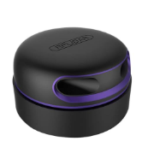
RGB-D Camera — Intel RealSense D435i
- 카메라 영상에서 YOLOv8s로 장애물·신호등·교통표지판을 실시간 검출/분류
- SCNN으로 차선을 연속적·견고하게 추정하여 차선 유지/차로 변경 판단 보조
- 상기 결과를 종합해 전방 위험 감지, 신호 준수, 표지 인식, 차선 유지 등 핵심 인지 기능을 제공
- Use YOLOv8s on camera frames to perform real-time detection/classification of obstacles, traffic lights, and traffic signs.
- Apply SCNN to robustly and continuously estimate lanes, assisting lane keeping and lane-change decisions.
- Fuse these outputs to deliver core perception functions: forward hazard detection, traffic signal compliance, sign recognition, and lane keeping.

Field | Spec
Modality | RGB + Depth (Active Stereo), built-in IMU (accel/gyro)
Depth FOV (H×V) | ≈ 87° × 58°
Operating Range (Depth) | ≈ 0.3–3 m (scene-dependent; up to ~10 m per tech sheet)
Max Depth Mode | 1280×720 @ 30 fps (depth)
RGB Example Mode | 1920×1080 @ 30 fps (typical)
Max Frame Rate (depth) | up to 90 fps (lower resolutions)
Interface / Power | USB 3.x (single-cable data + power), 5 V via USB
Physical | ~90×25×25 mm; ~200 g (vendor listing)
Primary Use | Obstacle / traffic-light / sign detection (YOLOv8s input), lane cues support; depth ROI for distance
Depth FOV (H×V) | ≈ 87° × 58°
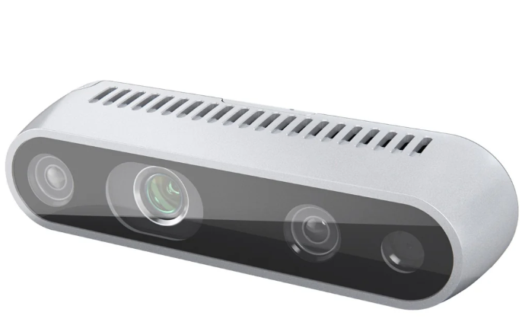
Motor Encoder — US Digital E8T-720-125 (pre-gearing) + Hardware Digital Tachometer
- FOC/속도 폐루프 제어 피드백: 전기각·속도·위치 피드백 제공 → 저속 토크/추종성 향상.
- 주행 계측: 휠 속도/이동거리(오도메트리) 산출, 안전 제한(과속/슬립) 로직에 입력

- FOC / closed-loop speed feedback: Provides electrical angle, speed, and position feedback to improve low-speed torque and tracking performance.
- Vehicle metering: Produces wheel speed and traveled distance (odometry) and feeds them into safety limit logic (overspeed/slip detection).

Constants
Name | Value | Unit | Notes
meters_per_count | 6.865916e-06 | m/count | x4 quadrature, r=0.033 m, gear (13/70)*(19/37)
counts_per_wheel_rev | 30199.19 | counts/rev | = 2880 / ((13/70)*(19/37))
wheel_circumference | 0.207345 | m | = 2pi0.033 (for reference)

Formulas
Quantity | Formula (plain text) | Output unit
Distance | distance_m =  encoder_counts*meters_per_count | m
Speed (from counts/s) | speed_mps =  counts_per_sec*meters_per_count | m/s
Counts per wheel rev (derivation) | counts_per_wheel_rev =  2880 / ((13.0/70.0)*(19.0/37.0)) | counts/rev
meters_per_count (derivation) | meters_per_count = ((13.0/70.0)*(19.0/37.0)) * (2pi*0.033) / 2880.0 | m/count
